A Teacher’s Guide to Spying during the British Civil-Wars
‘Intrigues which at that time could best be managed and carried out by ladies’
The History of The Rebellion, Edward Hyde, Earl of Clarendon
Spying formed an important part of the war effort for both sides during and after The British Civil Wars. In fact, it has been suggested that part of the reason for the royalist defeat was that the Parliamentarians developed superior systems of military intelligence and espionage. Sir Thomas Fairfax remarked that one of his spies ‘very often hazarded his life in bringing me from the Enemies Quarters exact Intelligence of their affaires’
Spy rings (groups of spies or ‘intelligencers’) used ciphers, invisible ink and fake envelopes with cover addresses as well as personal, puzzle-like paper locks, to keep their correspondence safe. They eavesdropped on enemy conversations, intercepted written communication, and bribed informants.
Female spies were particularly effective. The seventeenth-century belief that women operated exclusively within the domestic realm and were less capable than men of rational thought gave them a useful invisibility and a superior freedom of movement. When captured and interrogated they were more likely to be released and, even when found guilty, they avoided execution.
These ‘she-intelligencers’ were deeply involved in crucial information gathering and plotting, taking advantage of female attributes and occupations to extend their influence beyond the usual societal constraints. Lady D’Aubigny hid the instructions for a royalist uprising in her hair in order to smuggle them from Oxford to London. Female booksellers sewed messages into book covers and took advantage of the life of a travelling salesperson to move freely from place to place. Jane Whorewood, ‘agent 409’, couriered large sums of cash to Oxford in barrels of soap and was central to the operation of Charles I ‘s three unsuccessful attempts to escape from imprisonment at Carisbrooke Castle.
After the execution of the King, Britain was ruled as a republic by Oliver Cromwell as Lord Protector. The Sealed Knot was a secret royalist organisation that plotted for the restoration of the Monarchy. Cromwell’s spymaster, John Thurloe, hunted enemy spies. His spy-catchers intercepted royalist communications, systematically opening letters. Royalist spies took advantage of the prevailing belief that female correspondence was mainly trivial gossip, using recognisably female handwriting, names and subject matter as cover for secret messages.

Further reading:
Nadine Akkerman, Invisible Agents; Women and Espionage in Seventeenth Century Britain (Oxford: Oxford University Press, 2018)
John Ellis, To Walk in the Dark; Military Intelligence during The English Civil War 1642-1646 (Stroud: Spellmount, 2011)
https://www.english-heritage.org.uk/visit/places/carisbrooke-castle/history/jane-whorwood/

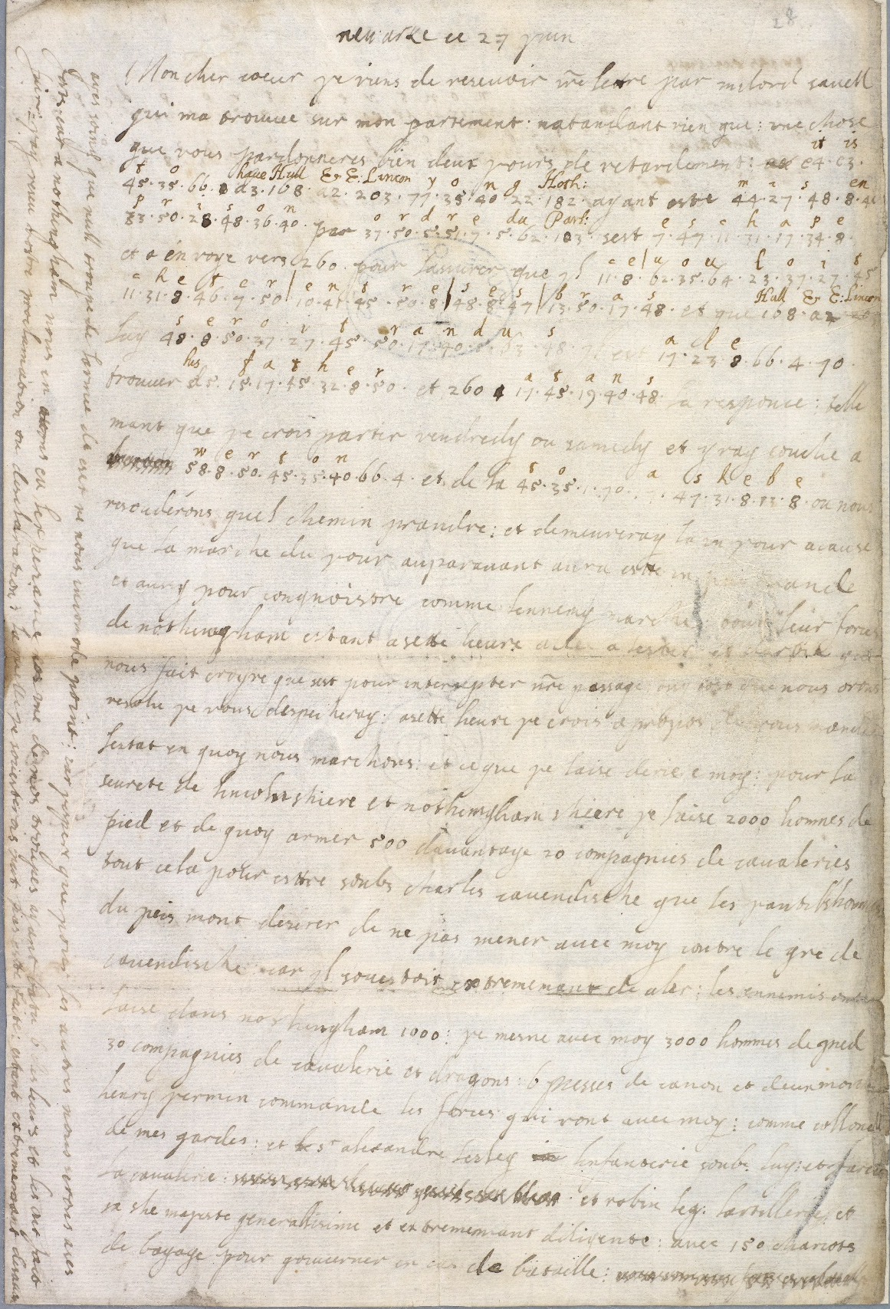
This letter was written by Queen Henrietta Maria to King Charles I and is written in French and in code. We can see the annotations made by parliamentarian code-breakers after they captured the letter. The Queen’s words were published to prove that the King was controlled by his wife, something seen in the seventeenth century as comical and shameful, a symptom of the natural order turned upside down.

Included with the kind permission of the Parliamentary Archives

